KickStarter My Chart

# Background

“Over two billion dollars have been raised using the massively successful crowdfunding service, Kickstarter, but not every project has found success. Of the over 300,000 projects launched on Kickstarter, only a third have made it through the funding process with a positive outcome.

Since getting funded on Kickstarter requires meeting or exceeding the project's initial goal, many organizations spend months looking through past projects in an attempt to discover some trick to finding success. For this week's homework, you will organize and analyze a database of four thousand past projects in order to uncover any hidden trends.” [1]

The above background is from the homework instruction. Since I never heard about the Kickstarter before, the context is not enough to understand and analyze the data. By some further research about the target, several important findings are listed below.

1. Kickstarter’s funding campaign follows the “all-or-nothing” funding procedure.
2. The backer cannot be investor but “supporter” with potential rewards provided by the project creator such as “a copy of what's being produced, a limited edition, or a custom experience related to the project”.
3. The funding goal and timeframe are set by the creator with the campaign storyline. The campaign storyline normally will include the reward section.
4. Kickstarter website has its search engine with special filters such as “Project we love” and “Trend”. [2]

# Questions and discussions

1. What are three conclusions we can make about Kickstarter campaigns given the provided data?
2. What are some of the limitations of this dataset?
3. What are some other possible tables/graphs that we could create?

Since investment is not accepted by Kickstarter, the conclusion is presented through the generic and the potential creators’ views with three discussions: Categories, Dates, and Goals. The limitation of the dataset is discussed at the last section individually. More tables and graphs have been added through the whole discussion in the below.

## Conclusion and Discussion one: Categories

The figure 1 shows the distribution between the main applied categories and the counts of the state. Most applications were found to focus on the “Theater” category. And top three absolute successful state counts are in the catalog “theater”, “music”, and “film & video”. Moreover, the category “journalism” has not developed their best way to utilize or is not suitable with Kickstarter’s platform based on its few application and unsuccessful states.

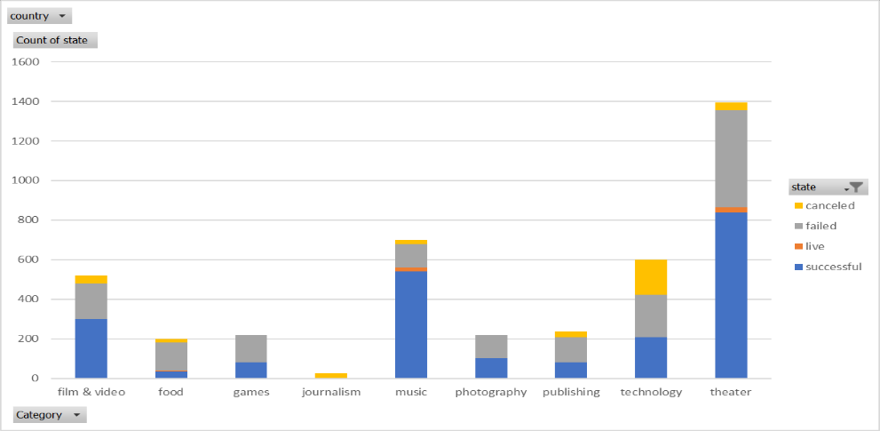

Figure 1 Funding Categories’ Counts of the States

By expanding into the subcategories’ counts of the state in the Figure 2, the “plays” dominated the application and the absolute successful state counts, which followed the above finding from its main category “theater”. The results also show that high successful possibilities are in “Rock”, “Hardware”, “Documentary”, and “Indie Rock” subcategories, while high failure possibilities are in “animation”, “drama”, “fictions”, “food trucks”, and several other subcategories.

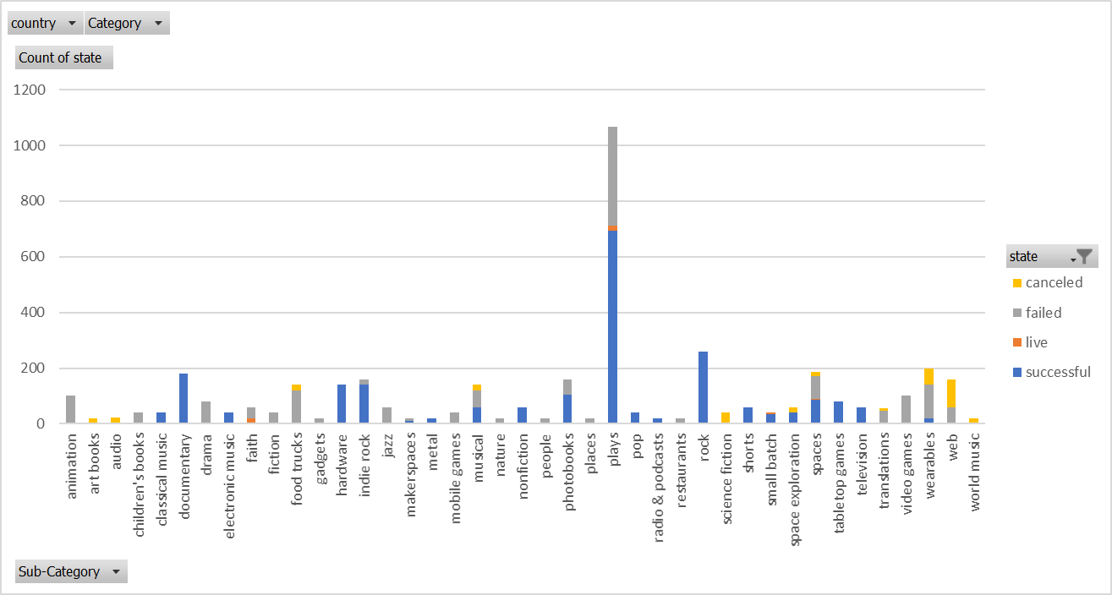

Figure 2 Funding Sub-Categories’ Counts of the States

The discussion from all categories’ point of view is generic. It may not be helpful for the potential project creators since they will be in a specific field. In the above figures how successful the historical applications are implicit and blended in with unrelated directions. Because of it, the successful ratio of the total state in different subcategories should be studied. The below are the two interesting examples.

Music in the main category plot shows a high successful possibility. But by reviewing within the catalog with successful ratio as the Figure 3, the musicians in the “faith”, “jazz”, and “world music” may want to reconsider to use Kickstarter for the fund raise. Meanwhile, musicians in other subcategories can directly refer to the historical templates from other artist to reach a promisingly successful funding campaign.

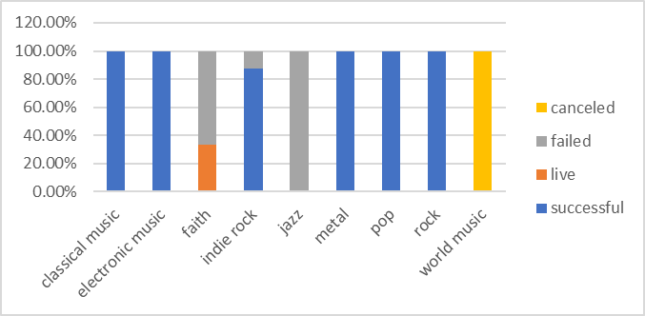

Figure 3 Successful Ratio of Sub-Categories’ State in Music Category

Food in the main category plot presents a discouraging result in Figure 1. However, by looking into the successful ratio into the subcategory as the Figure 4. The small batch type of food campaign shows 100% successful or live status. While the food trucks and restaurants creators can only take the previous examples as the failure lessons.

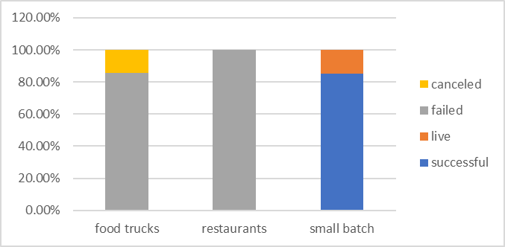

Figure 4 Successful Ratio of Sub-Categories’ State in Food Category

## Conclusion and Discussion Two: Dates

The figure 5 below shows the relationship between the month of the created conversion and the counts of the state. The canceled campaigns show a very stable trend while the successful campaigns seem to be more dynamics through the whole year. December is the only month when the successful campaigns are less than the failed campaigns, which the creators may consider avoiding it.

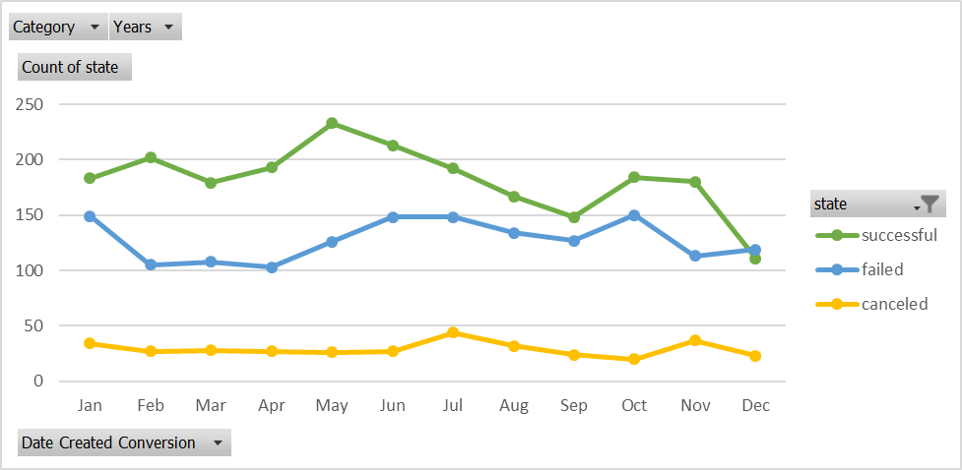

Figure 5 The Month Created Conversion and the Counts of the State

Another interesting data is the time frame that the previous projects had picked for the campaign. From figure 6, most of the pervious applications were favorable to set the funding campaign period around the one month or two-month period. However, from a successful ratio point of view, picking up the exact one month or two-month periods is all below the average successful ratio (around 53%) as the red line presented in figure 7, epically at the two-month period. It may indicate the creators with a better time frame idea had a clear plan or a keen motivation comparing the most creators using a “lazy” one-month or two-month estimates.

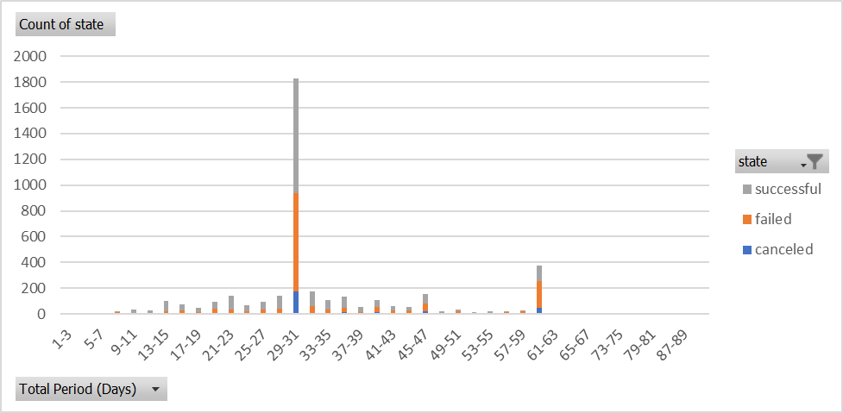

Figure 6 The Time Frame and the Counts of the State

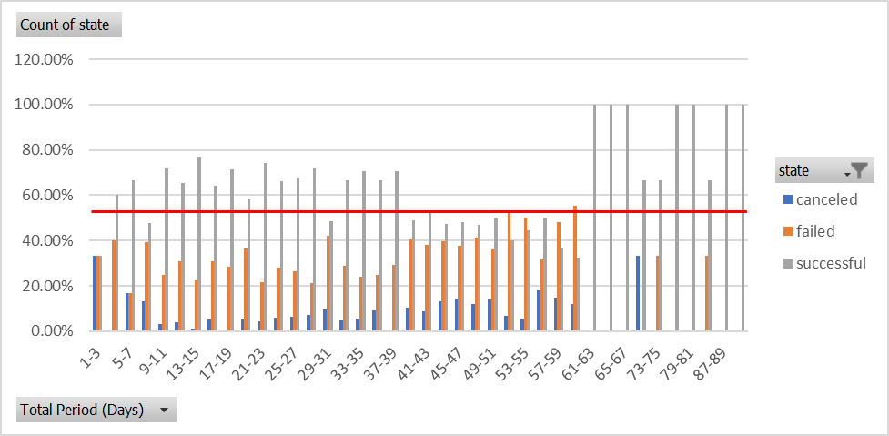

Figure 7 The Time Frame and the State Successful Ratio

## Conclusion and Discussion Three: Goals

The numbers of column “goal” in the dataset are converted to the USD by the below currency ratios in the Table 1.

Table 1 Currency Ratio to USD

|  |  |
| --- | --- |
| AUD | 0.72 |
| CAD | 0.76 |
| CHF | 1 |
| DKK | 0.15 |
| EUR | 1.13 |
| GBP | 1.28 |
| HKD | 0.13 |
| MXN | 0.049 |
| NOK | 0.12 |
| NZD | 0.68 |
| SEK | 0.11 |
| SGD | 0.73 |
| USD | 1 |

By using countifs function in Excel, the table 2 is generated from the dataset. Based on results in the percentage successful, percentage failed, and percentage canceled columns in Table 2, the figure 8 shows the trends between different percentage of the state and the range of the goals. When the goals are small than the 5000 USD, the successful ratio is high and above 65%; between 5000 USD to 45000 USD the successful ratio is stable around 40% to 50%; for the goal higher than 45000 USD, the successful ratio starts to significantly decrease to be around 20 %.

Table 2 The Goals and The States

|  |  |  |  |  |  |  |  |
| --- | --- | --- | --- | --- | --- | --- | --- |
|  | Number successful | Number failed | Number canceled | Total | Percentage successful | Percentage failed | Percentage canceled |
| Less Than 1000 | 326 | 118 | 19 | 463 | 70% | 25% | 4% |
| 1000 to 4999 | 926 | 428 | 65 | 1419 | 65% | 30% | 5% |
| 5000 to 9999 | 385 | 288 | 55 | 728 | 53% | 40% | 8% |
| 10000 to 14999 | 171 | 142 | 37 | 350 | 49% | 41% | 11% |
| 15000 to 19999 | 96 | 93 | 18 | 207 | 46% | 45% | 9% |
| 20000 to 24999 | 52 | 70 | 16 | 138 | 38% | 51% | 12% |
| 25000 to 29999 | 62 | 67 | 15 | 144 | 43% | 47% | 10% |
| 30000 to 34999 | 32 | 31 | 14 | 77 | 42% | 40% | 18% |
| 35000 to 39999 | 28 | 29 | 6 | 63 | 44% | 46% | 10% |
| 40000 to 44999 | 20 | 13 | 5 | 38 | 53% | 34% | 13% |
| 45000 to 49999 | 7 | 12 | 5 | 24 | 29% | 50% | 21% |
| Greater than or equal to 50000 | 80 | 239 | 94 | 413 | 19% | 58% | 23% |

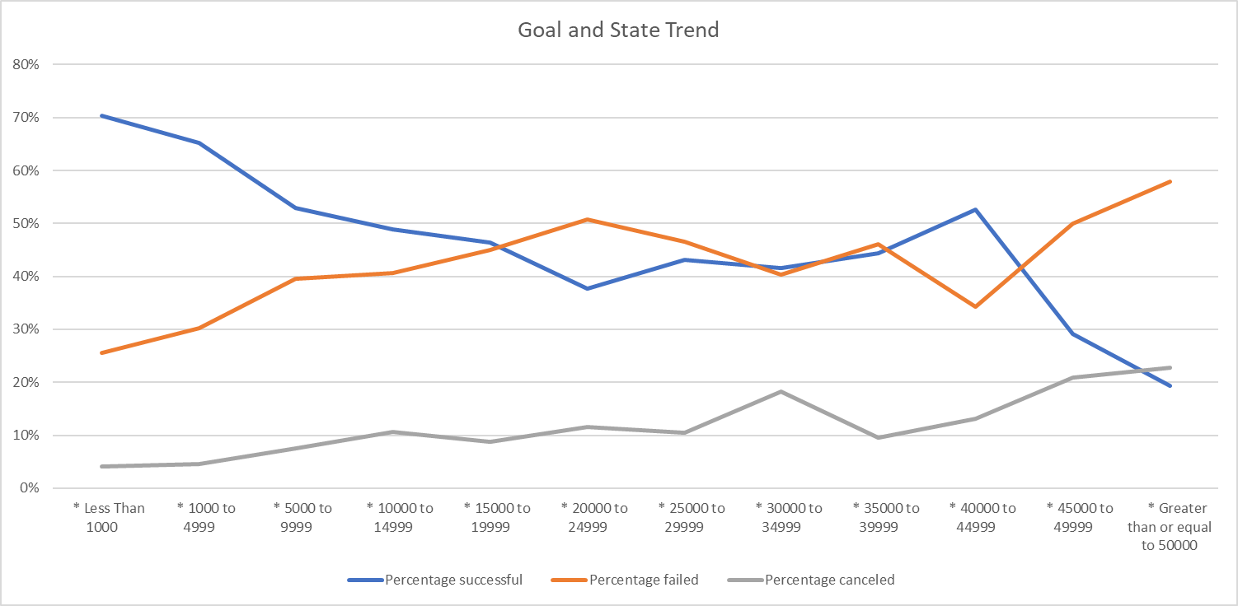

Figure 8 the Goals and the States’ Trends

Because in the data set there are still many projects (413 in total) above 50000 USD. By using PivotChart, further analysis is applied by expanding the goal range to 100000 USD by the gap of 5000 USD. As shown in the figure 9, the same conclusion shows that when the goal is above $45000, the successful ratio shows a significant and stable drop off the average successful ratio as the red line.

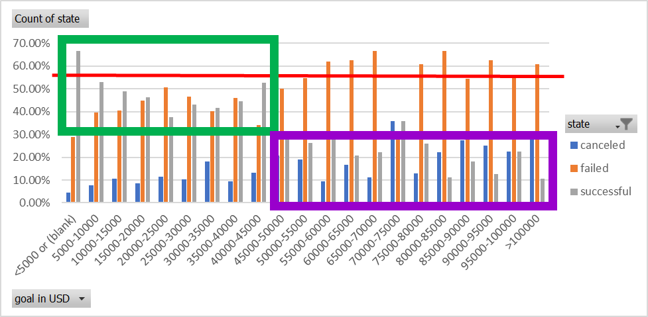

Figure 9 The Successful Ratio and the Goal

Another interesting result is presented with the distribution between the goals and the number of applications (the Counts of the State) in the figure 10 below. With the high successful ratio found above, Kickstarter is very suitable for funding campaign below 5000 USD. Historically it had most of the applications and the best chance to achieve the goal.

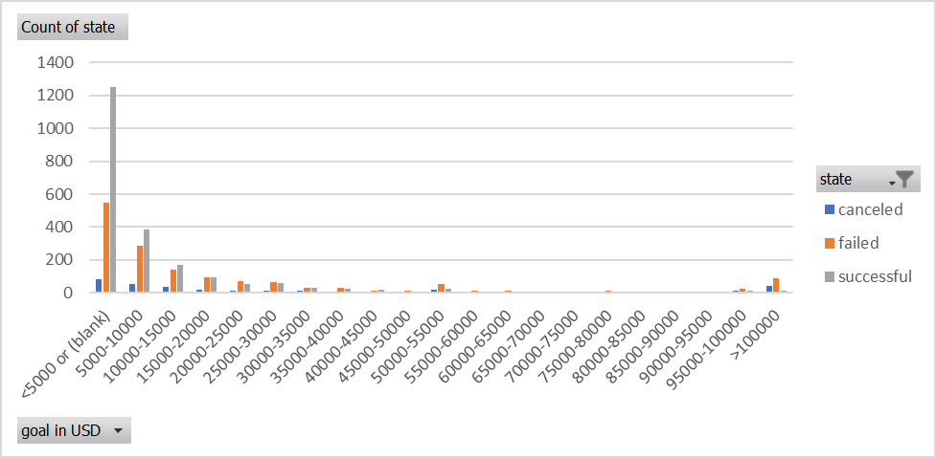

Figure 10 The Goals and the Counts of the State

## Data Set limitation and Further Thoughts

The data set itself needs some cleanup. There could be lots of “Junk projects” in the data. By defining P/G ratio as the pledged funds in USD divided by the goals in USD, there are more than 22% of the total campaigns received less than 1% of the goal. The creditability of those projects is very low for an open funding platform without difficult registrations. Even for the other 12% of the total projects which received only less than 10% of the goal, the sincerity of the project creators can be questioned. The potential creators or organizations who will study this dataset to catch the real trend or to learn some experience may need to only carefully study the rest of the 68% “sincere” cases, where more than 53% (78% of the “sincere” cases) are successful cases.

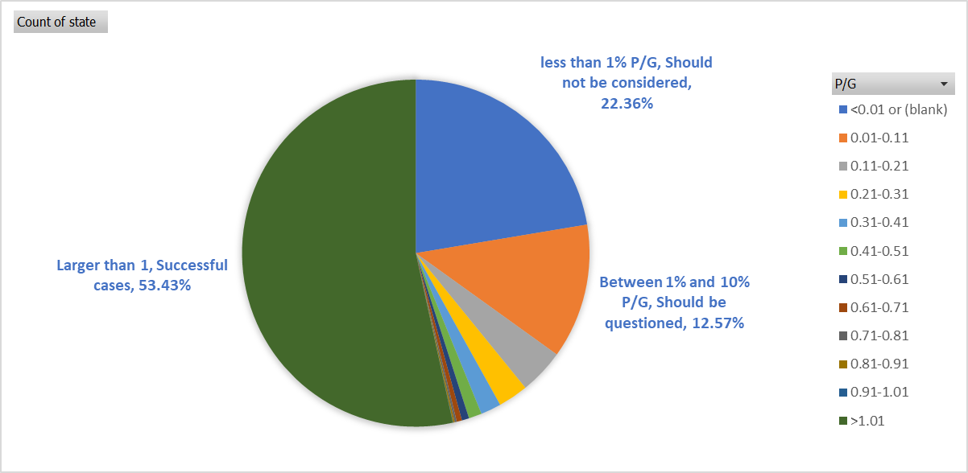

Figure 11 P/G ratio

There are some other impact factors from the Kickstarter which are not included in the dataset. Here list two examples

1. The search engine of Kickstarter for the potential backers. The filters of the search engine, the number of projects shown on the webpages, and the “Project we love” tag can strongly impact the accessibility for the backers’ selections.
2. The rewarding system. Due to no investment function, one of the major attractions for the backer is the instant reward with the finished project. Project related rewards and project unrelated rewards can be two interesting categories to study with different sub-categories. Take the food truck as example, this type of campaign cannot get much funds because they cannot deliver the hot and delicious food directly from the finished project but have to use unrelated reward such as T shirt. The experience between the creator and backer through the project is an important sale point of Kickstarter. Without it, the creator only has the compassion cards to play.

# Reference

[1] “# Unit 1 | Assignment - KickStart My Chart”, Trilogy Education Services

[2] Kickstarter 101, <https://help.kickstarter.com/hc/en-us/sections/115001095633-Kickstarter-101>